[Black Sea](https://www.google.com/search?safe=active&sca_esv=563733001&cs=0&q=Black+Sea&stick=H4sIAAAAAAAAAEVSPY_TQBT0RkpwHJASH0WUKoqEFEVIsZ2sHVNwEdCeIrhD0EWJP_Jh7zr2Wmc7Jb8AUVAjCkTBL6BAJzpSgKBAVBTXUaBrDwkJkrDPbDWanZn39u0Tiy2xS7qKiueGVmXOpLmgzXjuNJMg8u0N2l9qutrjsM-SlENVSUCwjMkAWKxpOZwbHOpLF7Qq8b0NKu9zozWOOO2mnsFpNVYMhdO2q6gcznrUAsWAEcppbIYJ0B5VGFTU1XWe0Xc5nFPT3CBpH4f7tDfnvIWjbfUrO7gawwMtxcs7tZfWKVTxKYVxGFFkgiRlNuMYr09dwvM8LQTFLGM-4MRI87axS8z8CfoKUjRrvJv7vlstNLCRB2VKuIIPMSPIwZSlY4513fIVkA9o3pmWhiv7f4zVhylOly5YU-YRGJI7cwmUVUk2iMFLIyXmXs9mMCdVG6iYe3GsZGvYBW88n56jc1Sp_rj8ftD4hp69-fAVfUZS-dFu0ZKF7cgjqXLsxCfBUWAv3Eweyrel8pFDpk7ERq7ckqS7ge87VrwIqHy9IUvVrpUT3e3qsta1B__-nq7SM1RoedrDt1-efyyNasL2PC7dHzbanZpUuheQyYLWflYF4dWfi8POgSSeTNKABiSrXX4qvDB_XRy26jvT8HfxxrBeaQptQd1lhDfrZx1hm_3k3ev3pYqIqoJWFAUZFW4V2mhdEIWrL4vlO_7E8prHzuRpCf0F1f02XmEDAAA&sa=X&ved=2ahUKEwjY6e_um5uBAxV2cmwGHaolA2YQ7fAIegUIABDyBQ)

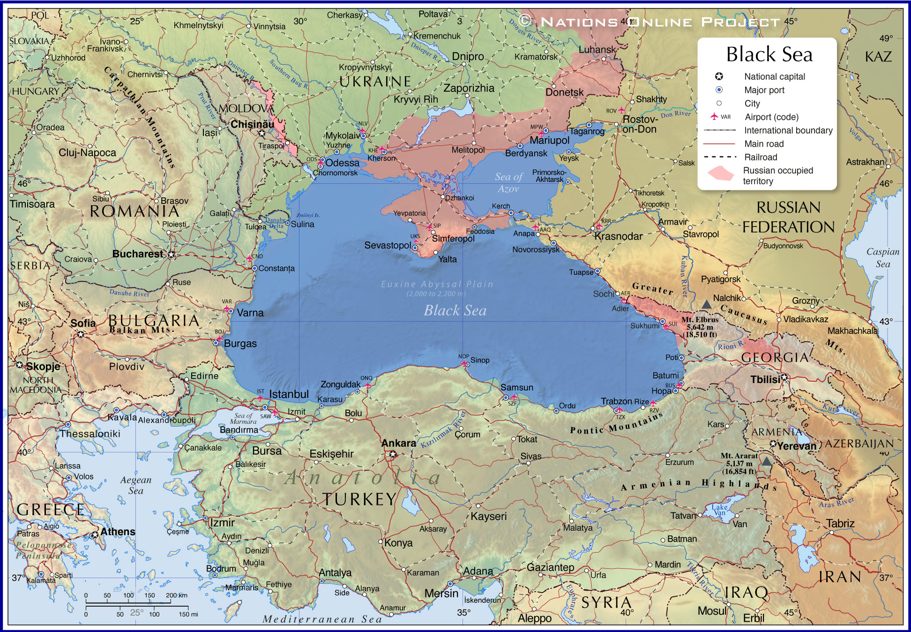

**blacksea.png**

The Black Sea is a marginal mediterranean sea of the Atlantic Ocean lying between Europe and Asia, east of the Balkans, south of the East European Plain, west of the Caucasus, and north of Anatolia. It is bounded by Turkey, Bulgaria, Romania, Ukraine, Russia and Georgia

e'x'a